**Struts 1**

* introduce

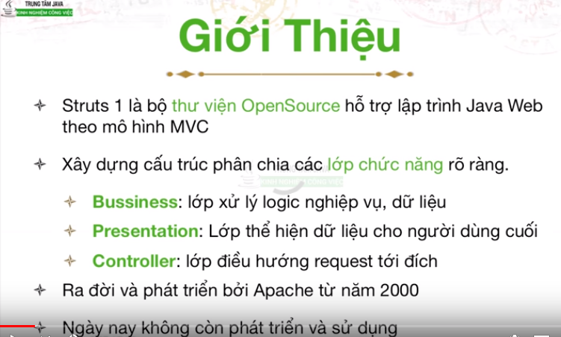

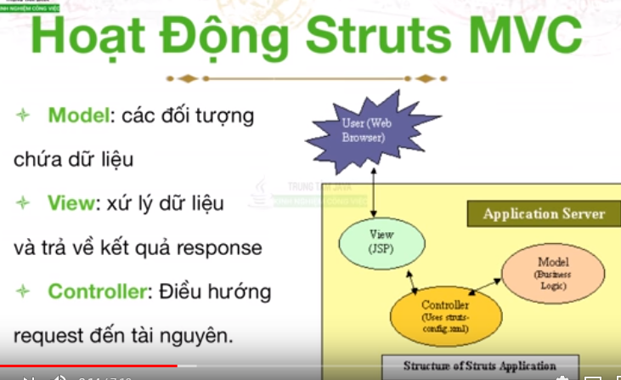

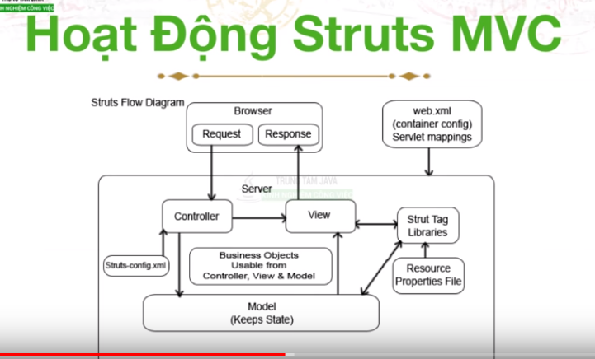

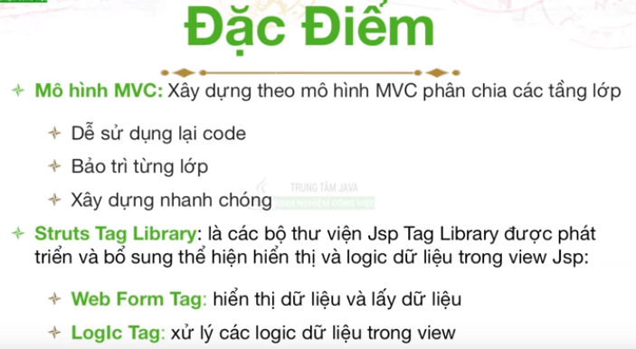

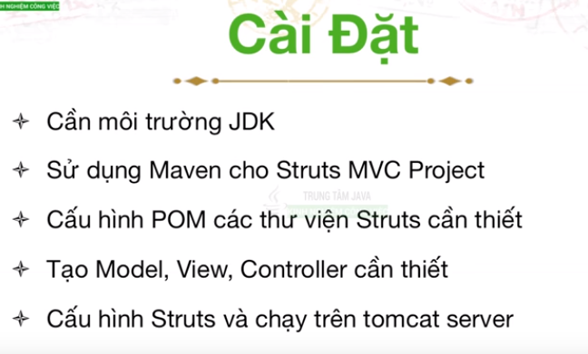

* Struts Action- Forward Action

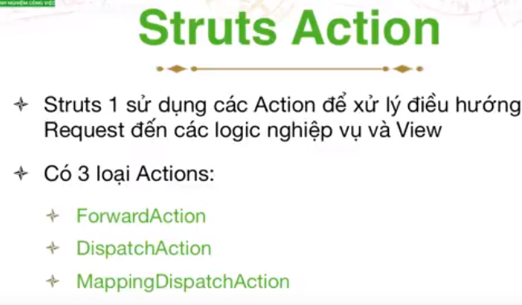

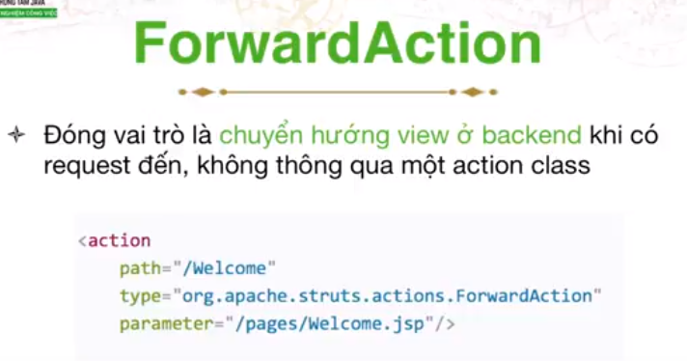

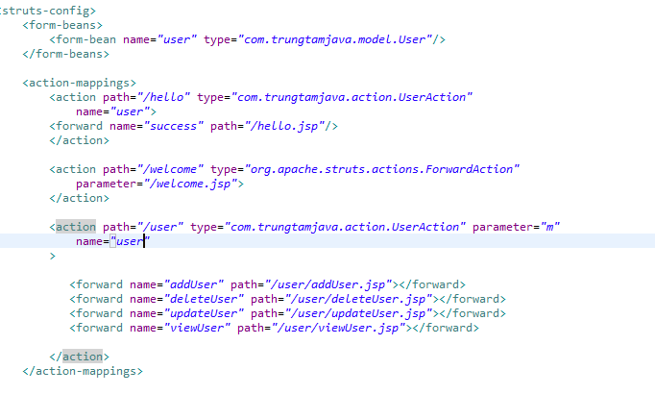

* Struts 1 DispatchAction

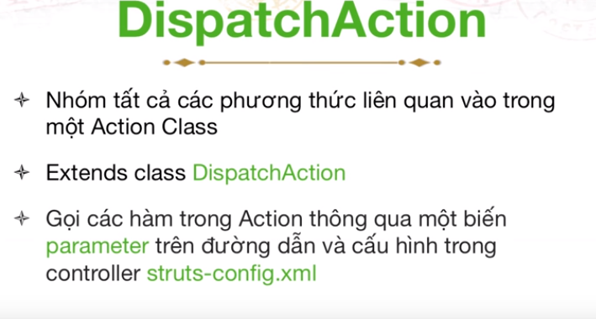

* Action

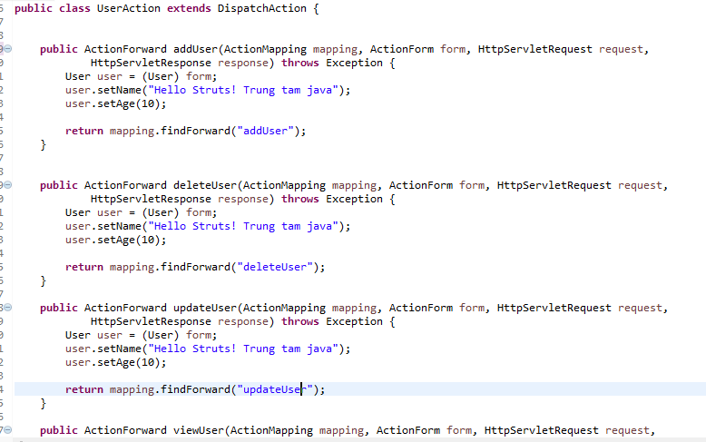

* File xml



URL : http://localhost:8080/HelloWorld/user.do?m=addUser

* Struts 1 – MappingDispatchAction

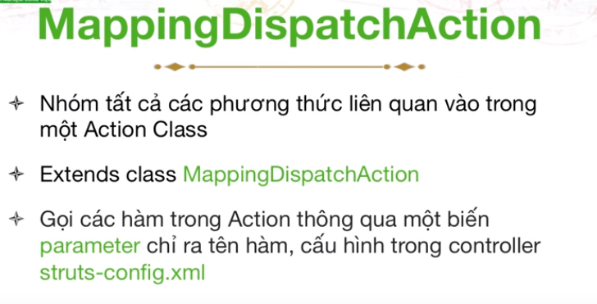

# Struts 1 - Request Parameter

# Form bean

# 

* Input

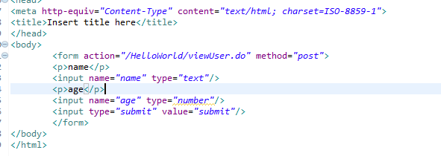

* Action

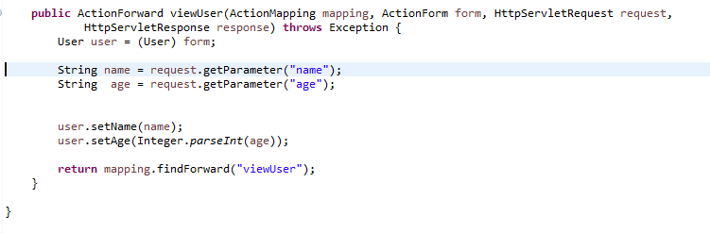

* Output

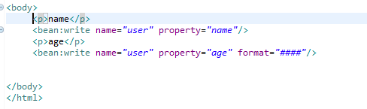

* Struts struts-form

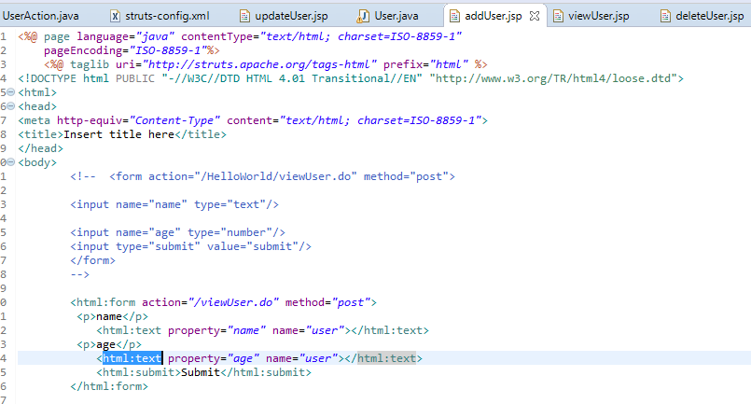

Input

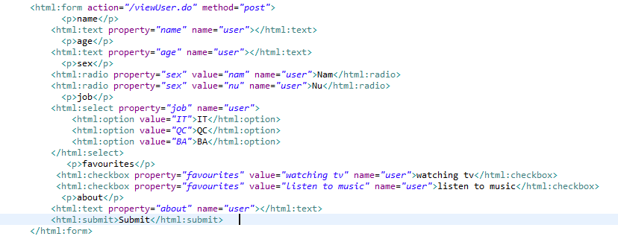

Output

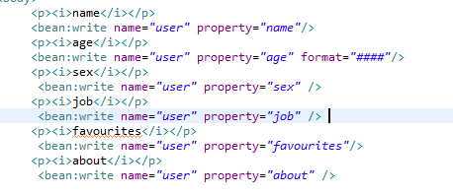

* Struts Messages

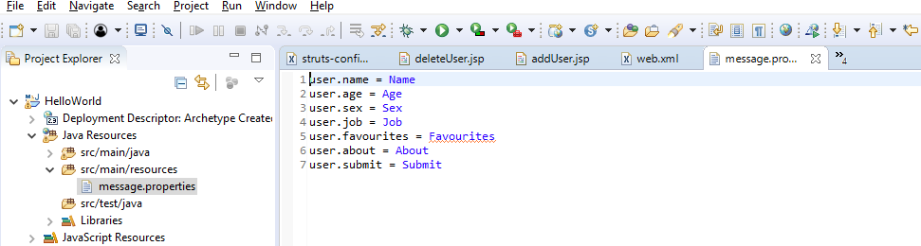

JSP

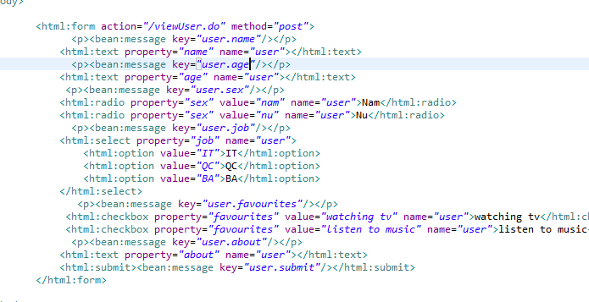

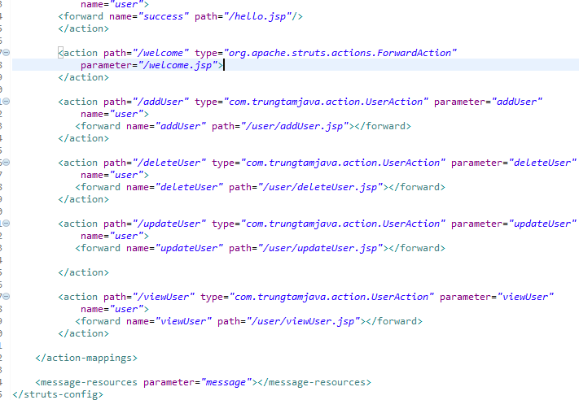

* Form validation
* File properties

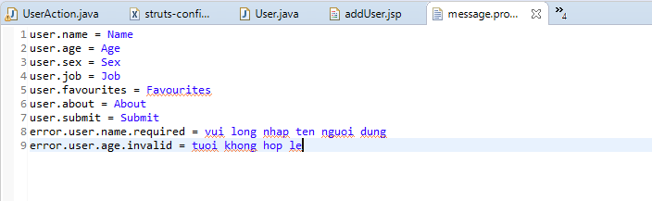

* In bean

Generate serialversionUID and override method validate

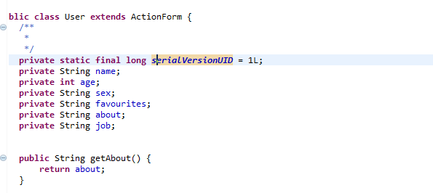

Key in file properties

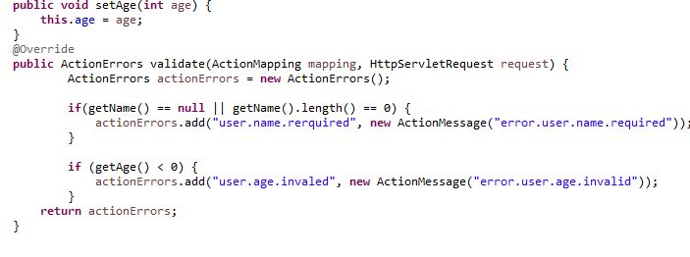

property

* In file input

Print all information error

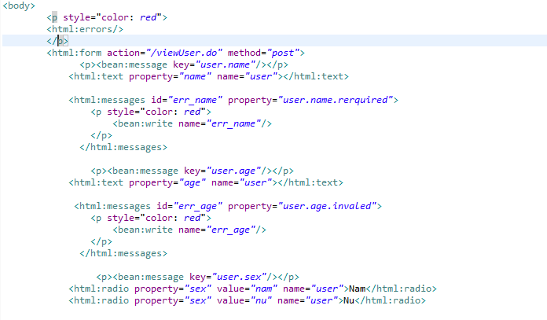

Print detail error

Property in method validate

* In file struts-config.xml

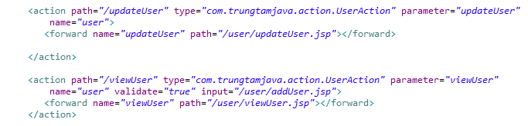

Return this path when apprear error

Result

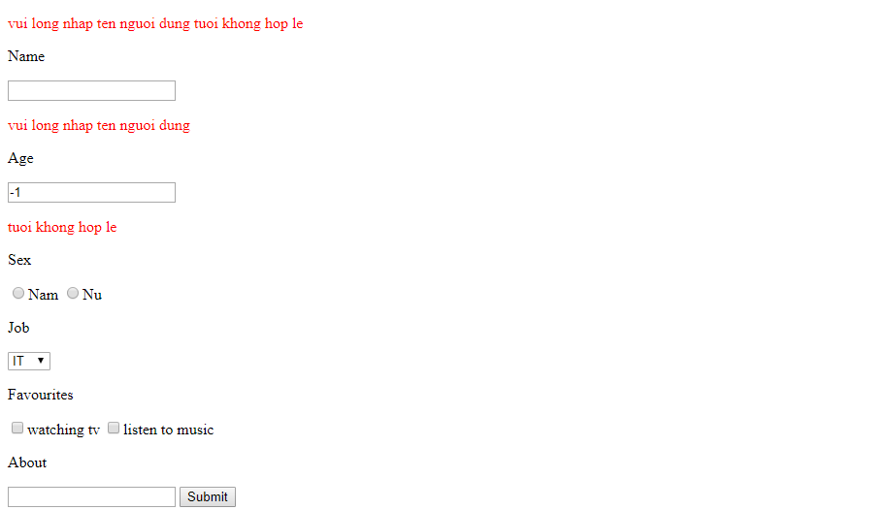

* Struts JDBC
* We have table USER in mySql

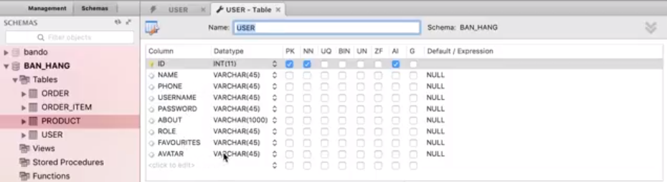

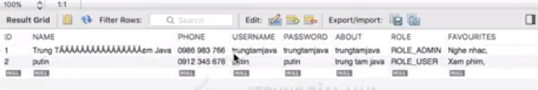

* In file pom.xml download dependency

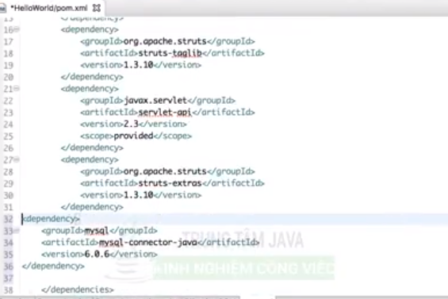

* Create package com.trungtamjava.utils

and class JDBCConection

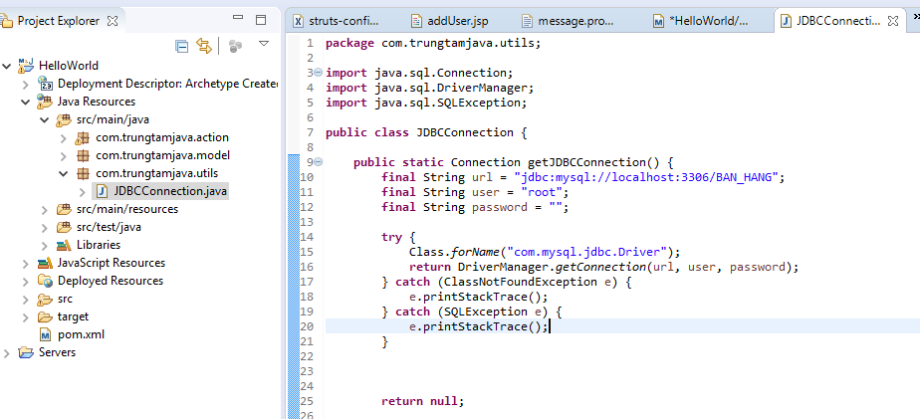

* In class User

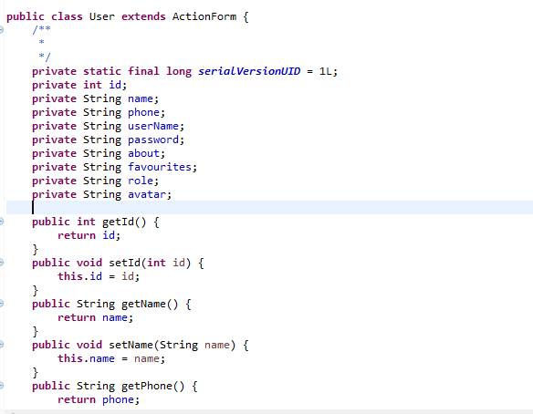

* Create package com.trungtamjava.dao

And class UserDao

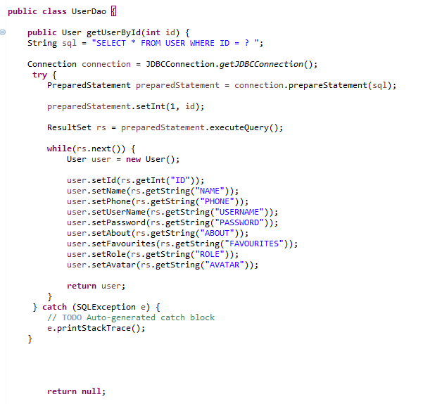

Write or get data from database

* In class action

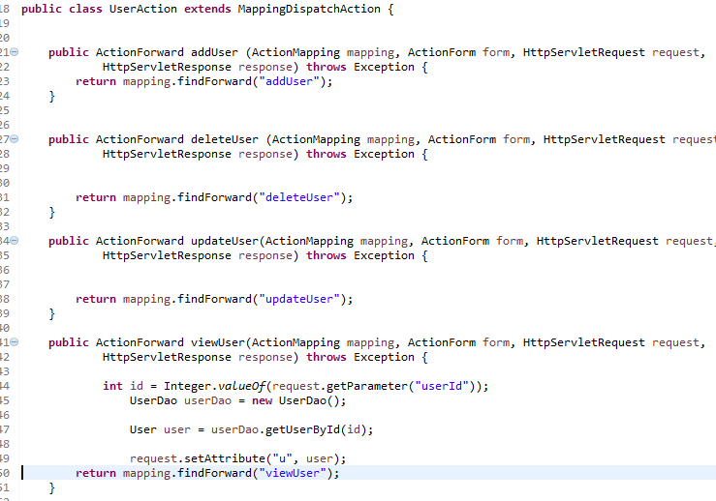

* Output

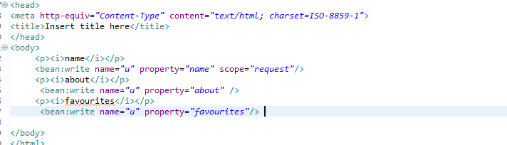

Result

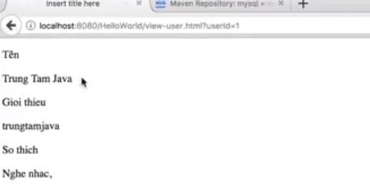

Data was got from database

* Clean Structure + struts MVC

Make code easy see and review

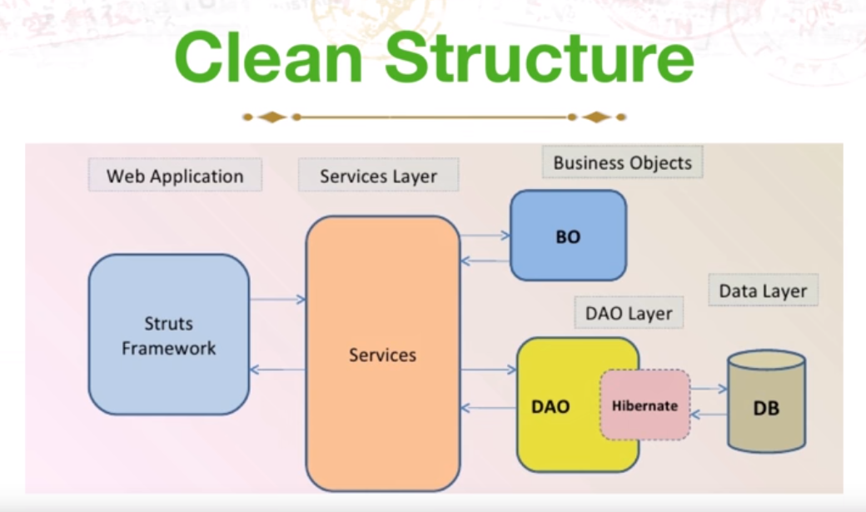

* Create com.trungtamjava.service

And class UserService (contact beween class Dao and Action)

* Class UserAction

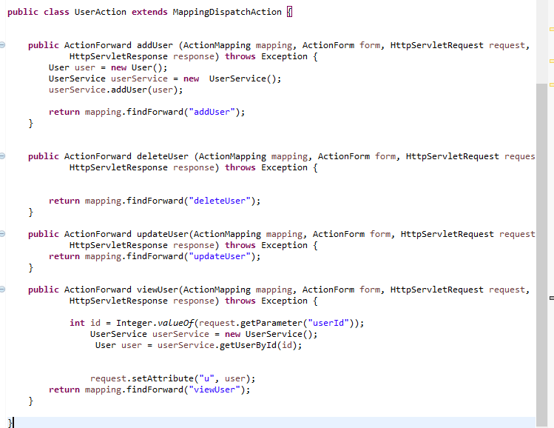

* Class UserService

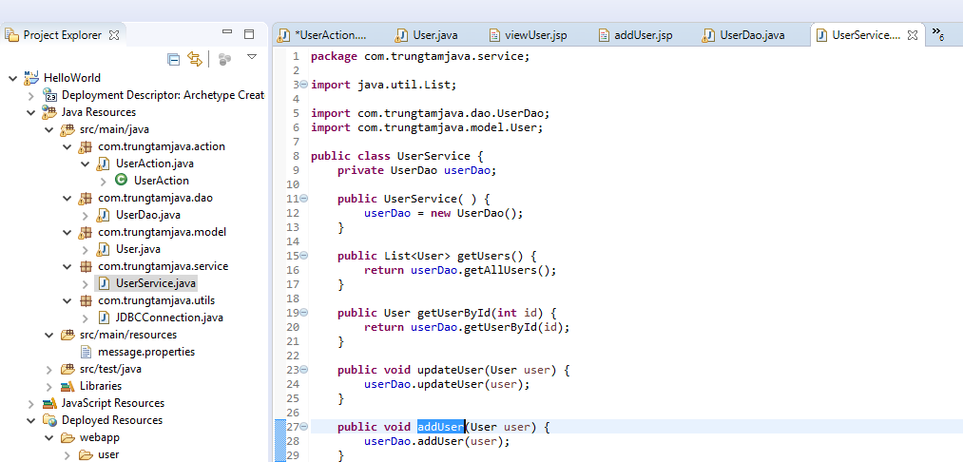

* Class UserDao

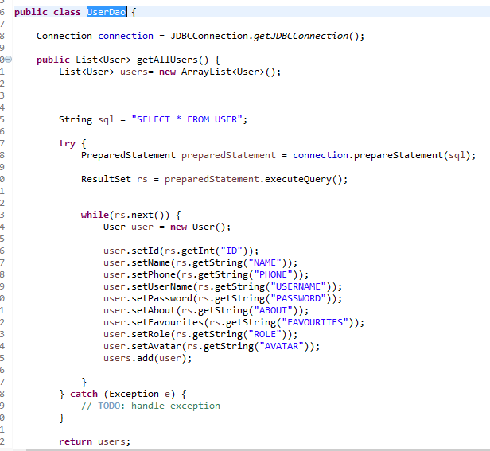

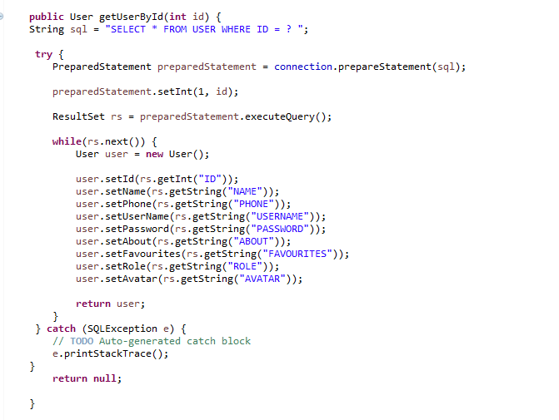

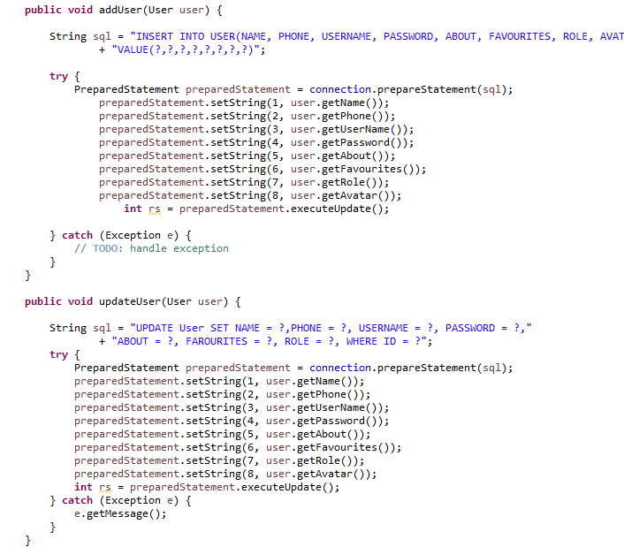

* Struts logic tag

Dùng để tính toán logic dữ liệu, lập đi lập lại dữ liệu trong vòng lặp for, so sánh dữ liệu bằng thông tin nào đó

* UserAction

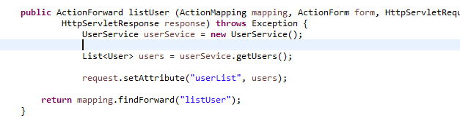

* ListUser.jsp

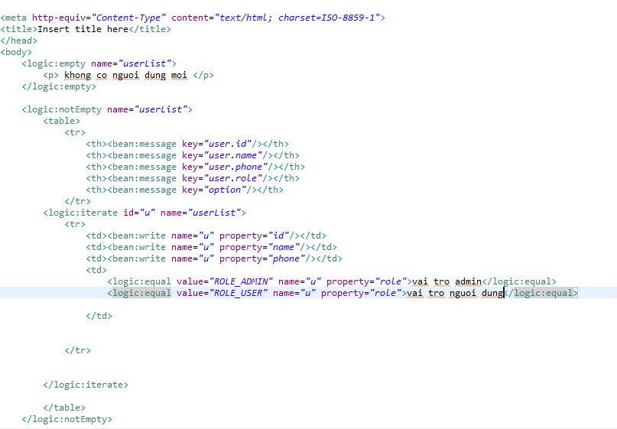

Similar to variable

Similar to loop for()

From file properties

From setAttribute() in action

Result

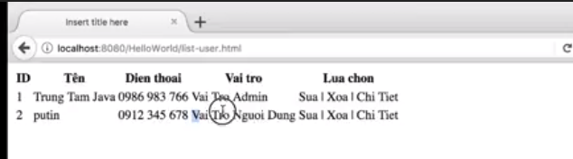

* Thực hành Struts 1
* Add user
* Start listUser

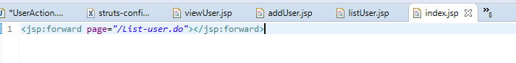

* Struts-config.xml

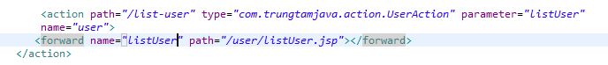

* UserAction

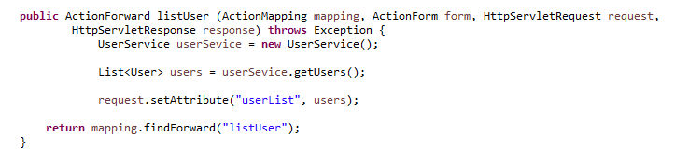

* ListUser.jsp

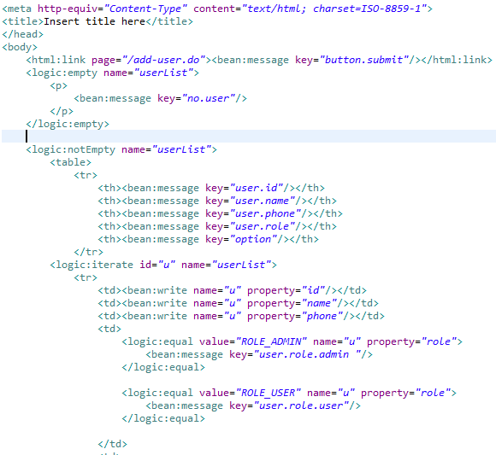

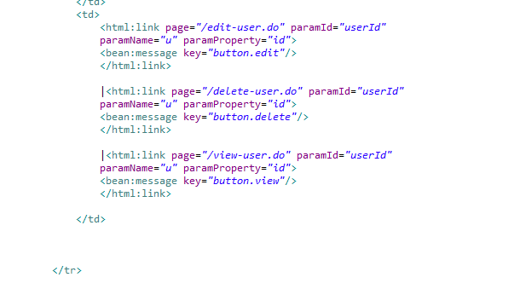

Result

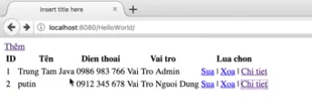

------------------Click them----------------

* ListUser.jsp

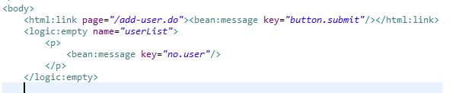

* Struts-config.xml

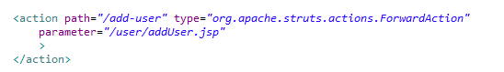

Result

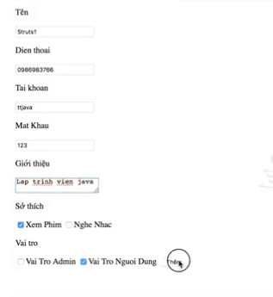

* AddUser.jsp

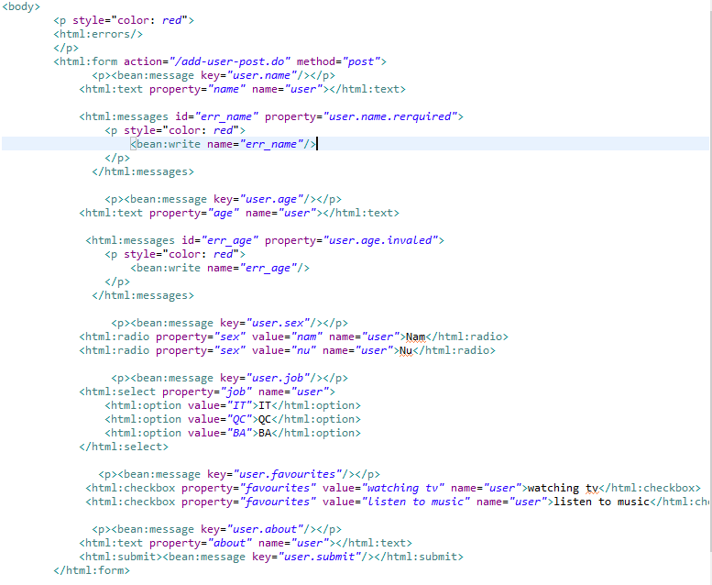

Redirect list-user.do to list user after add

* In struts-config.xml

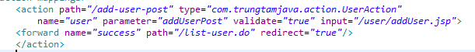

* UserAction

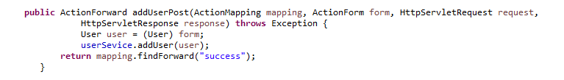

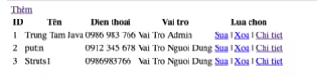 Result

* Delete
* In struts-config.xml

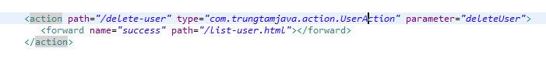

* In UserAction. Java

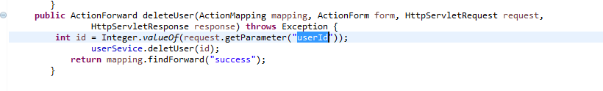

* Edit User
* In struts-config.xml

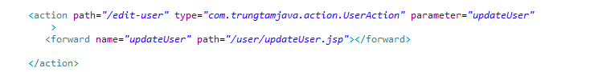

* 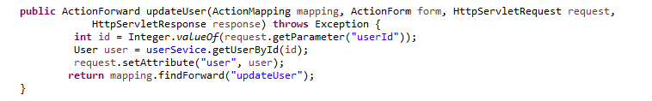in UserAction.java
* 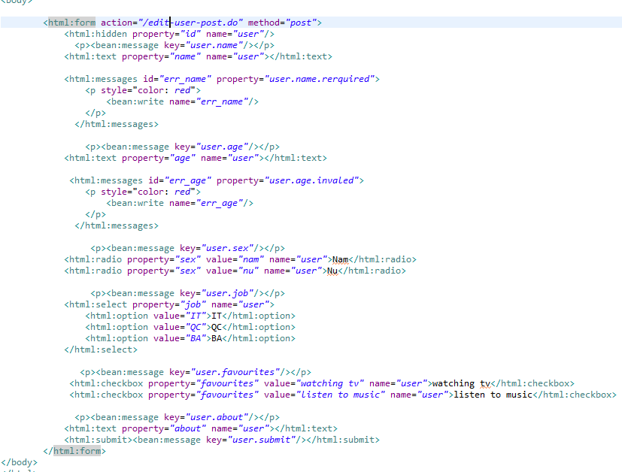in updateUser.jsp
* In struts-config.xml

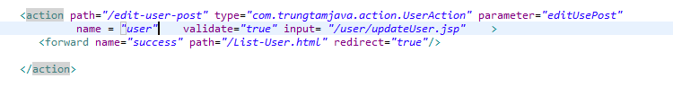

* In UserAction

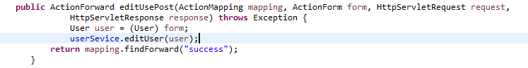

* Struts Log4j

Log các thông tin chương trình



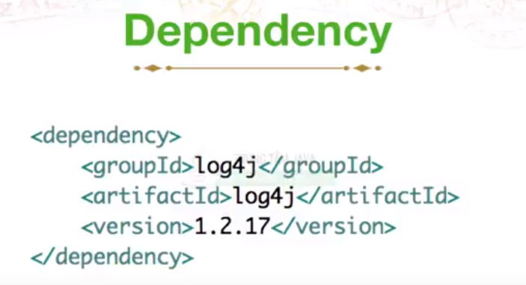

* 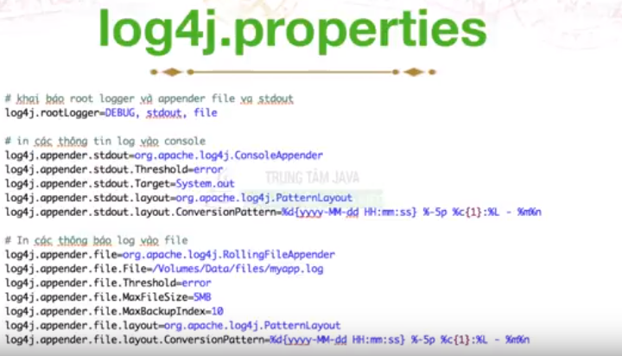create file log4j.properties in src/main/resources

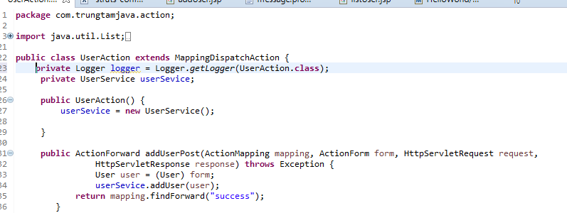

Log class error

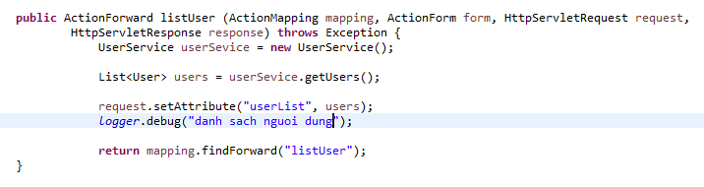

* Struts error handler

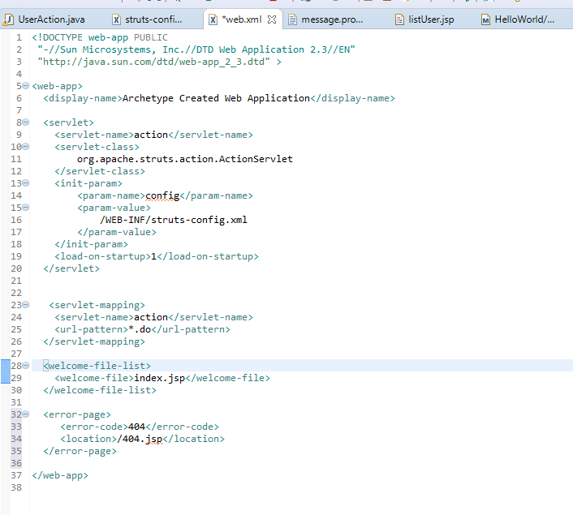

* In webapp create file 404.jsp

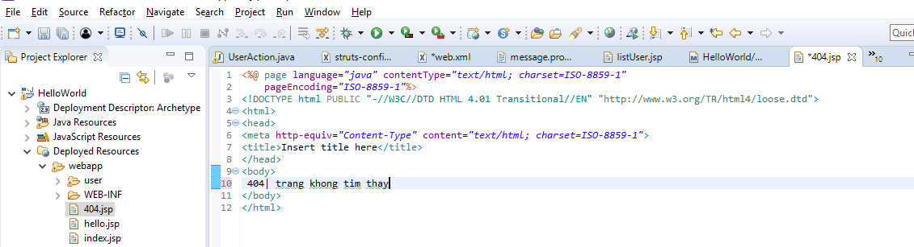

* Global exeption

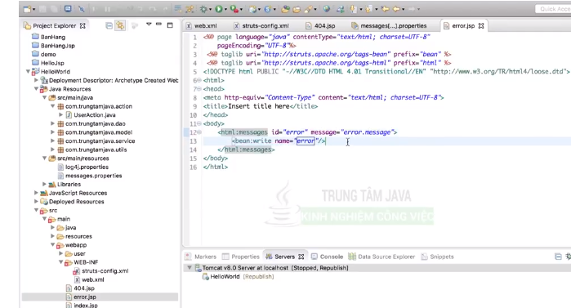

Create class MyExceptionHandler extend from ExceptionHandler

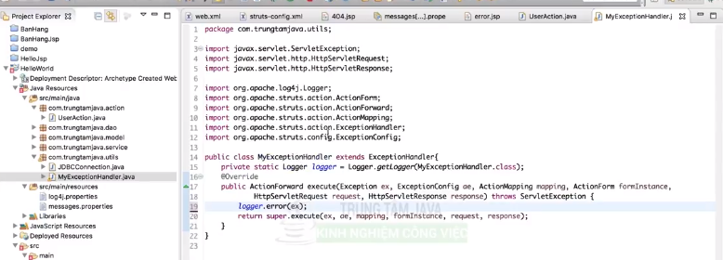

In file struts-config.xml

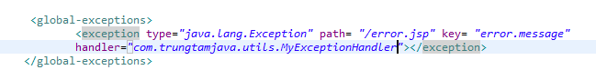

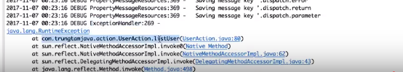

* Struts 1 đa ngôn ngữ
* Create class LanguageSelectAction

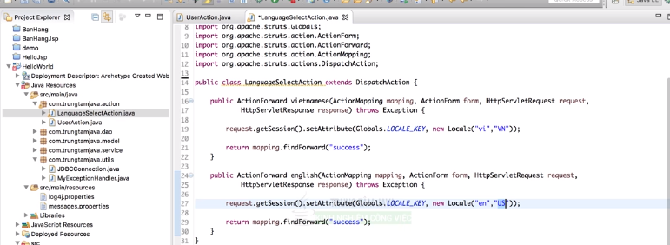

* File Struts-config.xml

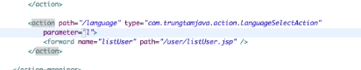

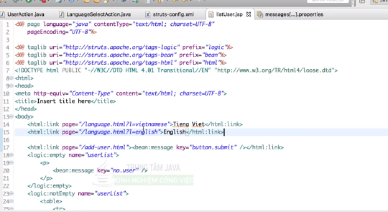

* Create file message.property by English and vietmese

